Highlighting Political Leadership offer: 2018/19 work update
Purpose

For information and decision.

Summary

This report updates members on our work priorities and engagement figures for the 2018/19 Highlighting Political and Managerial Leadership offer.

Recommendation

That the Improvement and Innovation Board notes the progress so far in 2018/19 and offers any comments on the Highlighting Political Leadership work.

Action

Officers to progress this work in light of the board’s comments.

Lead Member: | Cllr Judi Billing MBE
Contact officer: | Helen Jenkins
Position: | Principal Adviser - Leadership
Phone no: | 0207 664 3068
Email: | Helen.jenkins@local.gov.uk

Highlighting Leadership offer: 2018/19 work update

Background

- The LGA’s Highlighting Leadership offer forms part of our wider package of sector-led improvement. We offer a range of programmes, events and resources aimed at supporting and developing councillors at all levels. Attending our political leadership programmes gives councillors a unique opportunity to network with other members from different tiered authorities and often across the political spectrum. Our managerial leadership development programme starts by growing future talent with the National Graduate Development Programme, through to opportunities for senior officers with the flagship Solace IGNITE programme.

- This report provides an update regarding attendance at our leadership development programmes and commentary on the achievements of 2018/19.

Highlighting Political Leadership

“Would fully recommend any councillor given the opportunity to attend to do so. An enriching experience delivered by seasoned professionals whilst building and developing your councillor network.” – participant on Next Generation programme 2018

- The LGA continues to offer a wide range of development opportunities for councillors. Alongside flagship programmes such as Leadership Academy and Next Generation, the LGA offers specialised masterclasses and residential courses on topics such as scrutiny, finance, children’s services and planning. Our catalogue of programmes is regularly reviewed to ensure that it reflects what is relevant within the public sector and meets the needs of councillor attendees.

- Figures included in this report are correct up to and including March 2019. The figures represent both those that have already completed a programme and those that are pre booked onto scheduled programmes within the 2018/19 offer.

- Highlights in 2018/19 are:

5.1 Continued demand for our programmes – currently 836.

5.2 Leadership Academy participation has increased – it is particularly worth noting the gender balance has improved, with 47 per cent of Leadership Academy delegates being female in 2018/19 (compared to 37 per cent in 2017/18).

5.3 Participation on our Focus on Leadership events has significantly increased from last year from outturn figures of 77 in 2017/18 to 161 in 2018/19. This is primarily due to new programmes being included, due to popular demand, for example a new Women Councillors event.

5.4 100 per cent of respondents to the Next Generation impact survey said that participation had helped them improve the way they carry out their role

- 2018/2019 participation figures on the Leadership Academy (LA), Leadership Essentials (LE), Focus on Leadership (FoL), the Leader’s Programme (LEAD), Next Generation (NXG) and “Leading Edge” are set out in the tables which follow.

Political Leadership: Stats 2018/19 (as of 11 March 2019)
 | LA | LE | Fol | LEAD | NXG | LEDGE | Total
Labour | 53 | 221 | 98 | 3 | 19 | 4 | 398
Conservative | 59 | 188 | 28 | 5 | 22 | 4 | 306
Liberal Democrat | 4 | 24 | 21 | 2 | 12 | 1 | 64
Independent | 27 | 14 | 14 | 0 | 13 | 0 | 68
Total: | 143 | 447 | 161 | 10 | 66 | 9 | 836

Regional breakdown:

 | LA | LE | Fol | LEAD | NXG | LEDGE | Total
East of England | 13 | 47 | 19 | 2 | 7 | 1 | 89
East Midlands | 19 | 42 | 4 | 1 | 7 | 1 | 74
Greater London | 10 | 91 | 41 | 1 | 11 | 2 | 156
North East | 1 | 20 | 3 | 1 | 1 | 0 | 26
North West | 12 | 44 | 29 | 0 | 7 | 1 | 93
South West | 10 | 47 | 10 | 1 | 7 | 2 | 77
South East | 13 | 56 | 11 | 3 | 19 | 1 | 103
Wales | 47 | 0 | 0 | 0 | 4 | 0 | 51
West Midlands | 11 | 54 | 34 | 0 | 1 | 0 | 100
Yorkshire & Humber | 7 | 46 | 10 | 1 | 2 | 1 | 67
Total: | 143 | 447 | 161 | 10 | 66 | 9 | 836

How that compares:

Region | % of Cllrs on Highlighting Political Leadership Programmes | % of Cllrs across all English authorities
East of England | 11% | 13%
East Midlands | 9% | 10%
Greater London | 19% | 10%
North East | 3% | 4%
North West | 11% | 12%
South West | 9% | 20%
South East | 12% | 18%
Wales | 6% | 7%
West Midlands | 12% | 9%
Yorkshire & Humber | 8% | 6%

Breakdown by tier:

 | LA | LE | Fol | LEAD | NXG | LEDGE | Total
District | 42 | 90 | 26 | 6 | 25 | 2 | 191
County | 8 | 57 | 24 | 1 | 10 | 0 | 100
Metropolitan | 20 | 91 | 46 | 2 | 9 | 2 | 170
London | 10 | 91 | 41 | 1 | 11 | 2 | 156
Unitary | 16 | 98 | 22 | 0 | 7 | 3 | 146
Welsh | 47 | 0 | 0 | 0 | 4 | 0 | 51
Fire | 0 | 19 | 2 | 0 | 0 | 0 | 21
Parks | 0 | 1 | 0 | 0 | 0 | 0 | 1
Total: | 143 | 447 | 161 | 10 | 66 | 9 | 836

Breakdown by gender:

 | LA | LE | Fol | LEAD | NXG | LEDGE | Total | %
Male | 77 | 256 | 53 | 7 | 36 | 8 | 437 | 52
Female | 66 | 191 | 108 | 3 | 30 | 1 | 399 | 48
Total: | 143 | 447 | 161 | 10 | 66 | 9 | 836

Breakdown by ethnicity:
 | LA | LE | Fol | LEAD | NXG | LEDGE | Total | %
White British | 127 | 391 | 107 | 9 | 57 | 9 | 700 | 84%
Black | 3 | 20 | 21 | 0 | 0 | 0 | 44 | 5%
Asian | 12 | 30 | 28 | 1 | 9 | 0 | 80 | 10%
Mixed Race | 1 | 6 | 5 | 0 | 0 | 0 | 12 | 1%
Total: | 143 | 447 | 161 | 10 | 66 | 9 | 836

How this compares to the latest councillor census data:

 |  | LGA political leadership programmes | Councillor census 2018
Ethnicity | White British | 84% | 96%
 | Black | 5% | 1%
 | Asian | 10% | 2%
 | Mixed race | 1% | 1%
Gender | Female | 48% | 35.7%
 | Male | 52% | 63.3%

LA = Leadership Academy LE = Leadership Essentials
FoI = Focus on Leadership LEAD = Leaders Programme
NXG = Next Generation LEDGE = Leading Edge

Be a Councillor

- The LGA’s Highlighting Political Leadership offer provides support and development to councillors throughout their local government political career. We also recognise that prospective councillors will benefit from access to advice, information and guidance before making a decision about whether or not to stand. The “Be a Councillor” campaign focuses on raising the profile of the role of a councillor, with the aim that more people will choose to stand as a candidate.

- The 2018/19 “Be a Councillor” campaign continues to grow on the previous year’s refreshed programme. The following councils have engaged with the campaign in 2018/19:

Arun | Brighton & Hove | Chelmsford | East Devon
East Midlands Councils | Epsom & Ewell | Gloucester | Guildford
Hart | Huntingdonshire | Lancashire | Leeds
Lichfield | North Devon | Norwich | Reigate & Banstead
Uttlesford | Waverley | West Sussex | Wolverhampton

8.1 Support ranges from councils running bespoke events to full campaigns that include website and resources, using the “Be a Councillor” branding. For example:

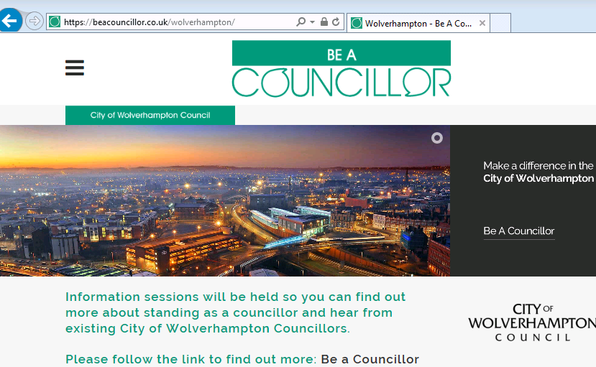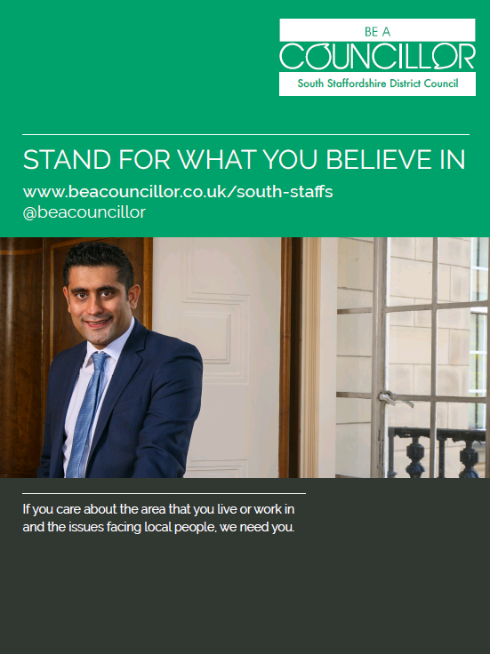

- This year “Be a Councillor” has maintained a communications focus celebrating the votes for women centenary and encouraging young people to get involved in local politics. On International Women’s Day 2019 (8 March), the LGA launched a new toolkit:

- The toolkit was developed to help councils create the underlying policies, procedures, ethos and environment that encourages and empowers women, parents and carers to become local councillors and take on leadership positions. Members of the Improvement and Innovation Board are encouraged to promote use of the toolkit in their own councils.

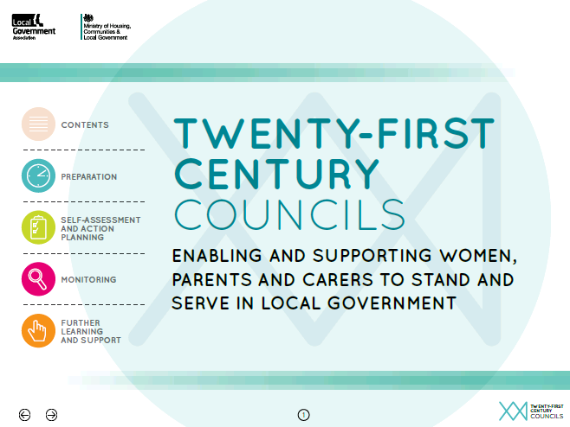

Online resources

- E-learning now has over 9,400 Members and the number of training options available continues to grow. In the last year, new modules have been introduced on commissioning of council services and GDPR/DPA 2018 and a module on equality and diversity is due to launch soon. A full review of the LGA’s e-learning platform is underway, and will focus on ensuring it is accessible, user-friendly and modern.

- Councillor workbooks continue to be a key element of the LGA’s blended learning approach to political leadership development. The latest edition is a revised and updated version of the “Engaging young people” workbook.

Community Leadership

- The Highlighting Political Leadership offer features a number of flagship programmes including “Be a Councillor”, the Leadership Academy and Next Generation. It is also worth noting for the Improvement and Innovation Board that the Leadership & Localism team offer a series of bespoke workshops for councils on topics including “effective ward councillor”, “chairing skills” and “Member/Officer relations”. These are delivered in partnership with the LGA regional teams, and are particularly popular during the first few months after election. Upcoming planned workshops include:

  - Braintree
  - Dacorum
  - Eastbourne
  - East Staffordshire
  - Horsham
  - Huntingdonshire
  - Kingston Upon Thames
  - Lewes
  - Manchester
  - Rochford
  - Ryedale
  - York.

- The content and catalogue of political leadership development is regularly reviewed to ensure that it is modern and relevant to the changing local government landscape. Members are asked to consider any topics they wish to recommend for future inclusion. In recent years, this has included adding an event for female councillors, as well as an emergency planning masterclass in the wake of the Grenfell tragedy.

Highlighting Managerial Leadership

- The LGA’s managerial leadership offer is underpinned by the understanding that the next generation of local government managers will be leading through unprecedented times. The LGA delivers a number of programmes that aim to develop the future pipeline of local authority chief executives, and enable current managerial leaders to be at the cutting edge of managing and implementing change.

- The LGA sponsors the Solace Group to deliver managerial leadership programmes to rising stars and executive leaders.

IGNITE

- 23 Chief Executive’s attended the Ignite programme in 2018. The headline survey results are highlighted below:

  - 100 per cent of respondents were very or fairly satisfied with Ignite
  - 100 per cent felt more confident in their ability to carry out their role
  - 70per cent said the objectives they had for taking part in Ignite were largely or fully achieved, 30 per cent said partially achieved
  - 100 per cent would recommend Ignite to others.

Total Leadership
“I have found the Total Leadership Programme to be inspirational and confidence building. It is quite hard at a senior level to find extra development but the programme has provided really varied (and challenging) content and an excellent selection of speakers. Having the space and time to reflect on that input and how it impacts on my role and my organisation has proved invaluable. I am taking that knowledge back into our Senior Leadership Team and I believe this has helped me personally become more effective and focused and for the organisation to really benefit from the investment in me.” – participant on the 2018 Total Leadership programme

- Total Leadership is aimed at executive leaders, whose next role is likely to be chief executive. The course runs over 12 months, with five residential events, plus online learning and action learning on real-time, work-based problems. The LGA fully funded three places on Total Leadership during 2018, and highlights from their feedback is below:
  - All three respondents (100 per cent) were very or fairly satisfied with Total Leadership.
  - All three respondents (100 per cent) said they felt more confident in their ability to carry out their role, having participated in Total Leadership.
  - All three respondents (100 per cent) said that the objectives they had for taking part in Total Leadership were largely or fully achieved.
  - All three respondents (100 per cent) would be likely to recommend Total Leadership to others if asked about it.

Springboard

- The Solace Springboard programme is a key element to the investment in developing the pipeline of future public sector leaders. Springboard is aimed at the head of service level officers, who are the rising stars of local government. 31 individuals took part in Springboard 2018, and 2019’s cohort have just been selected.

Transform

“The course content, delivery and networking opportunities were hugely beneficial.” – Participant on the 2018 Transform Programme

- The Transform programme was delivered to a select group of local government middle managers, who have a specific role to play within transformation and change programmes. The headline survey results are highlighted below:

  - 100 per cent of respondents were very or fairly satisfied with Transform
  - 100 per cent said they felt more confident in their ability to carry out their role
  - 100 per cent said the objectives they had for taking part were largely or fully achieved
  - 100 per cent said they would recommend Transform if others asked about it.

Inclusive leadership

- In partnership with Solace, the LGA is piloting a development event on Inclusive Leadership in the summer of 2019.

National Graduate Development Programme (NGDP)

- The ngdp assessment centres have now started for 2019 intake. Approximately 500 candidates have been taken through to assessment centres, and at the time of writing (14 March) there are 123 places confirmed on the programme. This is likely to rise, as organisations have until 31 March to register to take part.

- Following the last report to the Board, the Leadership & Localism Team have commissioned an external consultant to undertake a diversity review of the programme. The aim of the review is to produce a set of recommendations focused on further improving ngdp practices and support its objectives and aspirations. The consultant has been tasked with reviewing current data and good practice, gathering data through focus groups and interviews, analysis and making recommendations.

- To further enhance the reach of ngdp and widen participation amongst under-represented groups, a series of short new films are being recorded to feature current graduates talking frankly about what a career choice in local government means for them.

Next steps

- The Leadership & Localism Team are currently planning the 2019/20 programme. The Leadership Academy is currently out to tender, and members will be kept up to date through regular communication channels about progress.
- Members are requested to suggest or recommend any topics or themes for programmes that should be considered for inclusion within the 2019/20 programme.

Financial implications

- All programmes will be met from existing budgets.

Implications for Wales

- There are no implications for Wales.

